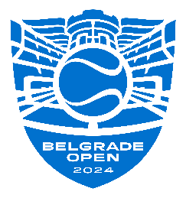

BELGRADE OPEN 2024 – OFFICIAL MEDIA ACCREDITATIONS

MEDIA:
NAME AND SURNAME:
CONTACT:
EMAIL:
ROLE (Enter X in the box, depending on how you would like to follow the tournament
JOURNALIST

FOTO JOURNALIST

VIDEOGRAPHER / CAMERAMAN

ACCREDITATION FOR ALL DAYS OF THE TOURNAMENT (answer YES or NO):
ACCREDITATION ONLY FOR CERTAIN DAYS (specify which):

